Module 2: Student Group Combination
This module solves the problem: "How can we form groups of students for projects or electives?"

1. Discrete Math Theory (The "Terms")
In Discrete Math, we use Counting Principles to determine the number of possibilities. There are two main concepts we will use:

A. Combinations ($C(n, r)$) — "Order Doesn't Matter"
- Concept: You have $n$ students, and you need to pick a group of $r$ students. A group of {Ali, Sara} is the same as {Sara, Ali}.
- Formula:
$$C(n, r) = \binom{n}{r} = \frac{n!}{r!(n-r)!}$$
- University Scenario: "Select 3 students from a class of 50 to form a Final Year Project group."

B. Permutations ($P(n, r)$) — "Order Matters"
- Concept: You have $n$ students, and you need to assign distinct roles (e.g., Leader, Coder, Presenter). Assigning {Ali (Leader), Sara (Coder)} is different from {Sara (Leader), Ali (Coder)}.
- Formula:
$$P(n, r) = \frac{n!}{(n-r)!}$$
- University Scenario: "Assign the top 3 students to the specific positions of President, VP, and Secretary."

C. Recursive Group Generation
- Concept: It's not enough to just count them ("There are 10 ways"). The system must list them (e.g., "Group 1: Ali, Bob. Group 2: Ali, Charlie...").
- Logic: We use Recursion to build a "Tree" of choices.
  - Step 1: Include Student A? (Yes/No).
  - Step 2: Move to Student B...
I got you. Let's break down exactly what is happening in that code. The math looks scary, but the logic is actually a simple "hack" to stop the computer from crashing.

1. The "Optimized Expressions" (The Math Hack)
You asked how I got to those weird loops instead of just writing factorial(n) / factorial(n-r).
The Problem:
Factorials get HUGE instantly.
- $10! = 3,628,800$
- $20!$ is huge.
- $21!$ is too big for a standard C++ variable (unsigned long long). It effectively "crashes" the math (overflows to 0 or random numbers).
If you try to calculate $C(50, 3)$ using the standard formula $\frac{50!}{3!(47!)}$, the computer tries to calculate $50!$ first, fails, and gives you the wrong answer.
The Fix (Cancellation):
We use high school math to cross out numbers before the computer ever sees them.

A. Permutations $P(n, r)$
Formula: $\frac{n!}{(n-r)!}$
Let's say $n=5, r=2$.
$$P(5, 2) = \frac{5 \times 4 \times 3 \times 2 \times 1}{3 \times 2 \times 1}$$
Notice that $3 \times 2 \times 1$ exists on top and bottom? Cancel them out.
Result: $5 \times 4 = 20$.
The Code:
Instead of calculating the whole factorial, we just multiply the first $r$ numbers

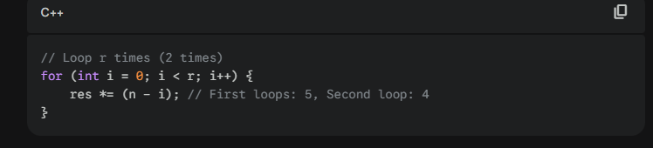
B. Combinations $C(n, r)$
Formula: $\frac{n!}{r!(n-r)!}$
Let's say $C(10, 2)$.
Instead of calculating huge factorials, we calculate it step-by-step to keep the number small.
We multiply by the "Permutation part" and immediately divide by the "r!" part loop by loop
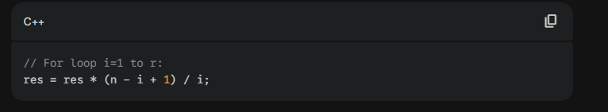
- Step 1 (i=1): $1 \times \frac{10}{1} = 10$
- Step 2 (i=2): $10 \times \frac{9}{2} = 45$
- Final Answer: 45. (We never had to calculate $10!$).

2. The "Recursive Part Shit" (Generating Groups)
This is the hardest part to visualize. Recursion here is just a way of building a Decision Tree.
Imagine you have 3 Students: {Ali, Bob, Cat}
You need to pick a Group of 2.
The recursive function generateCombinationRecursive asks one question for every student:
"Do we include this person, or skip them?"
Here is the trace of the code:
1. Start (Empty Group)
- Function looks at Ali (Index 0).
- Option A: Include Ali.
  - Group is now {Ali}.
  - RECURSE: Call function again, but now we need 1 more person, starting from Bob.
2. Inside "Option A" (Group = {Ali})
- Function looks at Bob (Index 1).
- Option A1: Include Bob.
  - Group is now {Ali, Bob}.
  - CHECK: Group size is 2? YES!
  - PRINT: "Group: { Ali, Bob }"
  - RETURN: Go back.
3. Backtrack (The "Remove" line)
- We just returned from A1. The code now runs currentGroup.remove(last).
- Group is {Ali} again. (We kicked Bob out to see if there are other options).
- Option A2: Skip Bob, look at Cat.
  - Group is now {Ali, Cat}.
  - CHECK: Group size is 2? YES!
  - PRINT: "Group: { Ali, Cat }"
  - RETURN.
4. Major Backtrack
- We finished everything with Ali.
- Remove Ali. Group is { } empty.
- Now start with Bob.
  - Group {Bob}... finds {Bob, Cat}.

The Code Explained Line-by-Line
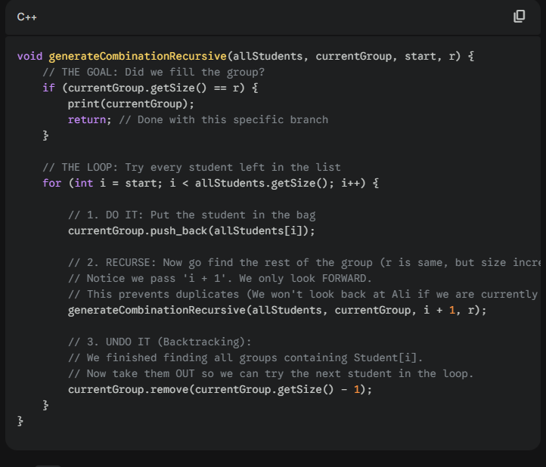

Why i+1? This is key for Combinations.
- If I picked Ali, I look at Bob. ({Ali, Bob})
- Later, when I start with Bob, I do NOT look back at Ali.
- Why? Because {Bob, Ali} is the same group. Passing i+1 ensures we only move forward, guaranteeing unique groups

